**TITLE**

**An Advance Task Manager Application for Android Devices**

**A CAPSSTONE PROJECTREPORT**

***Submitted to***

# SAVEETHA SCHOOL OF ENGINEERING

***By***

**KADIYALA BHARATHA RATHNA**

**(192224187)**

**VINOD.K**

**(192211822)**

**JAYANTH REDDY**

**(192210046)**

**Supervisor**

**DR. MARY VALENTINA**



**SIMATS ENGINEERING**

**SAVEETHA INSTITUTE OF MEDICAL AND TECHNICALSCIENCES,**

**CHENNAI – 602 105**

**Abstract:**

The huge growth of the mobile industry leads to more efficient software to be developed in compete with computer’s software but as it seems the problems will also to be carried out from this enhancement problems in the sense bug or misbehave of any software that can hang your device.so the Task manager would be needed for mobile devices too, where we can monitor what are all the applications are running and the complete package of information in one single Application. The Task Manager application shows all the device’s active applications, along with information about task manager will show how much processor power and a mobile phone or android platform. the mobile software and games are now powerful to cores the app is consuming, and the RAM item shows how much memory of RAM the app occupies. You can use Task Manager to end or turn off tasks that are taking too much CPU time or memory or that any bug containing app. You can click applications you want to stop and then click End Apps button. This project will provide the Active applications ( Applications that are currently running on the device), Installed (Applications that have been installed from the Play Store or any third party provider) RAM manager (Random Access Memory), Storage (Available memory storage), Network uses(Amount of internet data used), GPU ( graphics processing unit), Screen time (time spend on app in day), Internet Speed(speed of connected internet source) and Temperature(temperature of the whole device).

GANNT CHAT

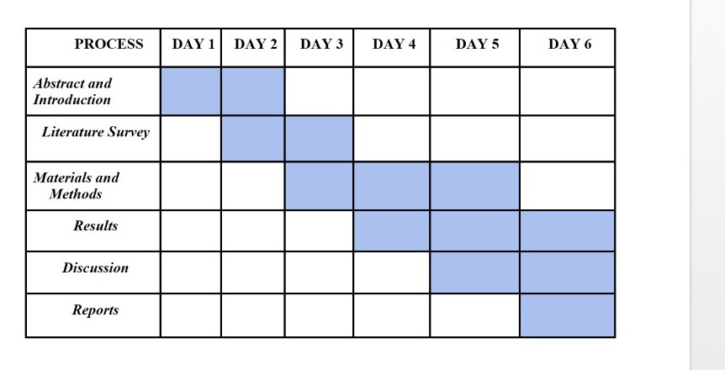

## FLOWCHART

**INTRODUCTION**

The task manager is kind of problem solver for user, whenever any bug causing application or task stuck your device, the user can call task manager to handle that situation and end or kill that bug containing task or application similarly we have seen this type of task manager in windows machine.no one can use windows machine without task manager. but now user will need that type of application in mobile devices also because mobile devices are getting powerful processor as well as applications. The task manager will handle CPU, RAM, GPU, network, disk and internet speed of your device means user can see that how much these things are used by individual active application and also force stop or end that application. it will also protect the user’s privacy from the malware applications, malware applications may be stealing your device.

**OBJECTIVES:**

The primary objectives of a task manager revolve around efficient task organization, monitoring, and optimization to enhance productivity and workflow management.

Firstly, task managers aim to provide users with a centralized platform to record, prioritize, and track tasks, enabling better organization and planning. This includes features such as task categorization, due date assignment, and task dependency management to ensure tasks are executed in a logical sequence.

Secondly, task managers facilitate effective communication and collaboration among team members by enabling task sharing, commenting, and assignment functionalities. This fosters transparency, accountability, and teamwork within an organization, leading to improved coordination and task alignment.

Moreover, task managers often include monitoring and reporting capabilities that allow users to track task progress, identify bottlenecks, and analyse productivity trends. This data-driven approach enables stakeholders to make informed decisions, allocate resources efficiently, and optimize workflows for better performance.

**LITERATURE REVIEW:**

A survey of current task manager application available on the Google Play Store and other platform will provide valuable insights into future, design, and experience aspects. Studies on automated process termination mechanism in task manager apps will be essential. Research papers, articles and documentation on algorithm, heuristics and best practices for safely and effectively terminating processes will guide the implementation for this future. By conducting a through literature survey encompassing these key areas, the “Task Manager (Android)” project aims to build a robust and future-rich application their devices processes and optimize performance**.**

**CONCLUSION:**

It is a complex application to design because we need to get ac- cess to all the administrative permissions in order to get pieces of information about CPU, ram, etc. or modify any other applications with following the user’s privacy policy. it’s very costly to develop because of its complex design and structure. developer modes not get much profit out of it. it’s not profitable application for developer because developers can not put advertisements in the task manager application.it will slow down the performance of the task manager. task manager is for fasten the devices but if the task manager itself slow down device then there is no meaning of that application. for the development of task manager application for android we have to read all the documentation of google android studio because there is no proper guidance on android application development. The task manager application is all in one application that pro- videos the user the transparency between system and user. it will fasten the user’s phone and protect from background key loggers or malware. it will save you from unresponsive mobile hangs.it is low memory highperformance application that will boost your mobile experience in a different way.it will divert the de- vice’s 100 % processing power to one individual application.